

**IUBAT** – International University of Business Agriculture & Technology

**Report No : 03**

**Report On : Display characters of a string one by one on a 7 segment display**

**Course Code : CSC 471**

**Submitted To :**

Md. Alomgir Hossain

Faculty, Department of Computer Science & Engineering

**Submitted By :**

Group Name :Net_Bug

Section : G

|  |  |  |
| --- | --- | --- |
| SL | ID | NAME |
| 01 | 16103325 | Md. Minhaz Ahamed |
| 02 | 16103333 | Saikat Kumar Saha |
| 03 | 16103342 | Rupol Ahmed |
| 04 | 16103343 | Abdullah Al Sabid |
| 05 | 16103352 | Joyanta Kumar Sarker |
| 06 | 16103373 | Md.Milon Sarker |
| 07 | 16103374 | Md. Solayman Hossen Selim |
| 08 | 16103388 | Md. Ushaed |
| 09 | 16103344 | Fahim Adnan |
| 10 | 16103378 | Maliha Tabassum Toma |

**Date of Submission** : 8th July , 2018

**INTRODUCTION:**

The Arduino is a microprocessor. A Microprocessor is a compact programmable computing device with memory, processing, input, and output pins works with lots of programming language as PID , C++ etc. In this lesson we will:

1. Build and wire a device with LED, resistor, and Arduino board.
2. Program the device to “Blink the Light”
3. Identify the flow of electricity / signal in this computing unit.
4. Use the Blockly Programming system to control speed of Blink.

**REQUIREMENTS:**

You will need--

1. LED Light Bulb (Any Color)



1. Various Colored Connecting Wires
2. Arduino UNO
3. PC/Laptop(for burning program)
4. USB
5. Switch(Optional)
6. Power Source

### [Arduino-UNO Schematic Diagram](https://forum.arduino.cc/index.php?topic=448819.0):

### C:\Users\mmarifat\Documents\CN-arduino-uno-fig1-enlarge.png

**WORKING PROCEDURE:**

We will divide the whole work into some sub-module. These are :

1. Installtion
2. Pre-manage
3. Working & Troubleshooting

**INSTALLTION:**

1. Make sure that we are having all of the components that we need to do this project.
2. We need to install Arduino software in PC/Laptop for coding.We follow the following process
   * 1. Download the software from <https://downloads.arduino.cc/arduino-1.8.5-windows.exe>
     2. Install .exe file in th PC using administrator mode.
     3. Open software and go Tools>Board>select Arduino UNO
     4. Again go Tools>Port>select COM*(What pc will show you)

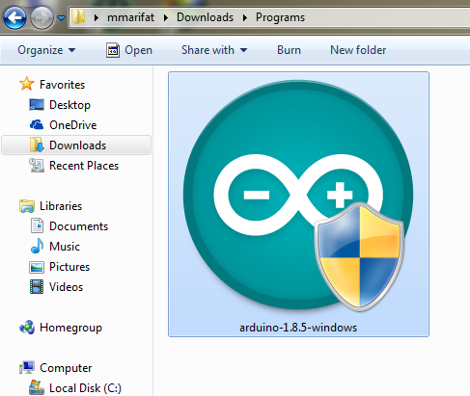

**PRE-MANAGE:**

1. In this stage we will do the hardware connection part.
2. Place a bread-board .Use the Power & GND side to place LED.
3. Connect “+pin” to the +5v input and “-pin” to the GND input .Pin-2 is connected to the GND of output.
4. Use wires to connect to Arduino pin 12,10,7 with the input +5v pin and Arduino GND with GND input.
5. These process will complete the connection between Arduino , Bread-board and components.
6. Now, write a program that will blink the LED’s as animation/pattern.

**WORKING & TROUBLESHOOTING:**

1. In this stage we will observe the whole project.
2. After burning the program that we write we will connect the power source to the Arduino Board .
3. Let the Arduino power up and the LED’s Blink as a animation formate.

**CODE:**

/* Code Made By Net_Bug Team Members*/

int e=7, d=8, c=9, b=10, a=11, f=12, g=13;

void setup()

{

pinMode(a, OUTPUT);

pinMode(b, OUTPUT);

pinMode(c, OUTPUT);

pinMode(d, OUTPUT);

pinMode(e, OUTPUT);

pinMode(f, OUTPUT);

pinMode(g, OUTPUT);

}

void loop(){

int i;

for(i=0; i<1; i++){

RakamGoster(i);

delay(1000);

}

}

void RakamGoster(int rakam){

switch(rakam){

case 0 :

digitalWrite(a,HIGH);

digitalWrite(b,HIGH);

digitalWrite(c,HIGH);

digitalWrite(d,LOW);

digitalWrite(e,HIGH);

digitalWrite(f,HIGH);

digitalWrite(g,HIGH);

break;

}

}**Curcuit Diagram:**

**Conclusion:**

After observing the whole process we can see that we are getting exact output that we are expecting.

**Alert:**

1. Connect the wires and pins very carefully as they are very lightweight.
2. Remove the power source as soon as the observation is done.
3. Don’t burn a program with existing program.